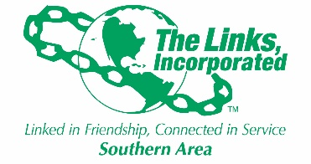

SERVICES TO YOUTH FACET MEETING
MONDAY, APRIL 20, 2026, AT 8:00 PM

AGENDA

- Call to Order Link Lisa Sido
- Prayer Link Robin Smith
- Minutes of last meeting Link Lisa Sido
- Update on Mobile Book Library at Woodhill Link Maya Feemster-Jones
Elem.
- Report on LIFE Umbrella Program Link Robin and Link Sido
- Update on Gaston Literacy Reading Soulmates Links Robin, Gloria & Jack
- Links Love HBCUs program update Link Leah and Link Jack
- Update on the National STEMS Program Link Lisa Sido
- Budget Discussion All Members
- Discussion on Project L.E.A.D Program Link Lisa Sido
(Links Erase Alcohol and Drug Abuse)
- Silent Auction Request & Payment All Members
- Matters Arising All Members
- Report on Family Literacy Initiative Link Christina and Link Brett
- Adjournment Lisa Sido

